**View Designer to Workbooks Transition Guide**

Contents

View Designer Overview 2

Workbooks Overview 2

Why Convert View Designer Dashboards to Workbooks? 2

Conversion Options 4

Overview Tile Conversion 5

View Dashboard Conversion 6

Getting Started 8

Updating Default View Designer Queries 9

Common Steps 10

Enabling Time Range Filter 10

Updating the Query to Consider the TimeRange Parameter 11

Enabling Sparklines 12

Advanced Cell Settings 14

Additional Parameters 15

Donut & List 16

Linechart & List 19

Number & List 22

Timeline & List 25

Additional Reference Materials 28

# View Designer Overview

View Designer is a tool offered through Azure Monitor. View Designer allows you to create custom views to help you visualize data in your Log Analytics workspace, with charts, lists, and timelines.

Link to additional [View Designer Resources](https://docs.microsoft.com/en-us/azure/azure-monitor/platform/view-designer)

# Workbooks Overview

Workbooks combine text, [log queries](https://docs.microsoft.com/en-us/azure/azure-monitor/log-query/query-language), metrics, and parameters into rich interactive reports. Workbooks are editable by any other team members who have access to the same Azure resources.

Workbooks are helpful for scenarios such as:

* Exploring the usage of your virtual machine when you don't know the metrics of interest in advance: CPU utilization, disk space, memory, network dependencies, etc. Unlike other usage analytics tools, workbooks let you combine multiple kinds of visualizations and analyses, making them great for this kind of free-form exploration.
* Explaining to your team how a recently provisioned VM is performing, by showing metrics for key counters and other log events.
* Sharing the results of a resizing experiment of your VM with other members of your team. You can explain the goals for the experiment with text, then show each usage metric and analytics queries used to evaluate the experiment, along with clear call-outs for whether each metric was above- or below-target.
* Reporting the impact of an outage on the usage of your VM, combining data, text explanation, and a discussion of next steps to prevent outages in the future.

Link to additional [Workbook Resources](https://docs.microsoft.com/en-us/azure/azure-monitor/insights/vminsights-workbooks)

# Why Convert View Designer Dashboards to Workbooks?

View Designer offers the ability to generate different query-based views and visualizations. However, many high-level customizations remain limited, such as formatting the grids and tile layouts or selecting alternative graphics to represent your data. View Designer is restricted to a total of 9 distinct tiles to represent your data.

Workbooks is a platform that unlocks the full potential of your data. Workbooks not only retains all the capabilities, but also supports additional functionality through text, metrics, parameters, and much more. For example, Workbooks allows users to consolidate dense grids and add search bars to easily filter and analyze the data.

While this guide offers simple steps to directly recreate several of the commonly used View Designer views, Workbooks allows users to have the freedom to create and design any of their own custom visualizations and metrics. Below is a snapshot of what Workbooks is capable of creating

[The Workspace usage template from Workbooks](https://go.microsoft.com/fwlink/?linkid=874159&resourceId=Azure%20Monitor&featureName=Workbooks&itemId=community-Workbooks%2FAzure%20Monitor%20-%20Workspaces%2FWorkspace%20Usage&workbookTemplateName=Workspace%20Usage&func=NavigateToPortalFeature&type=workbook)

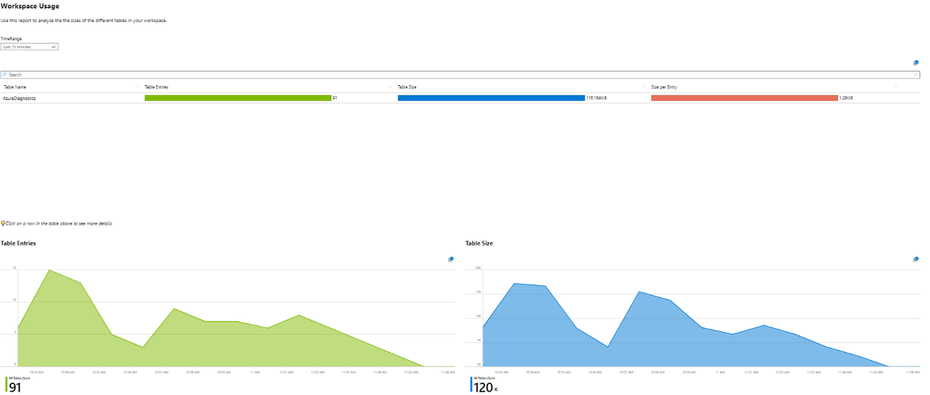

# Conversion Options

View Designer has a fixed static style of representation, while Workbooks enables freedom to include and modify how the data is represented, below depicts a few examples of how one might transform the views within Workbooks.

[View Designer – Vertical](https://go.microsoft.com/fwlink/?linkid=874159&resourceId=%2Fsubscriptions%2F5c038d14-3833-463f-a492-de956f63f12a%2Fresourcegroups%2Faul-rg%2Fproviders%2Fmicrosoft.operationalinsights%2Fworkspaces%2Faul-test&featureName=Workbooks&itemId=%2Fsubscriptions%2F5c038d14-3833-463f-a492-de956f63f12a%2Fresourcegroups%2Faul-rg%2Fproviders%2Fmicrosoft.insights%2Fworkbooks%2F5a0ba062-7246-4907-b03f-eed8b55bf1f7&workbookTemplateName=View%20Designer%20Vertical&func=NavigateToPortalFeature&type=workbook)

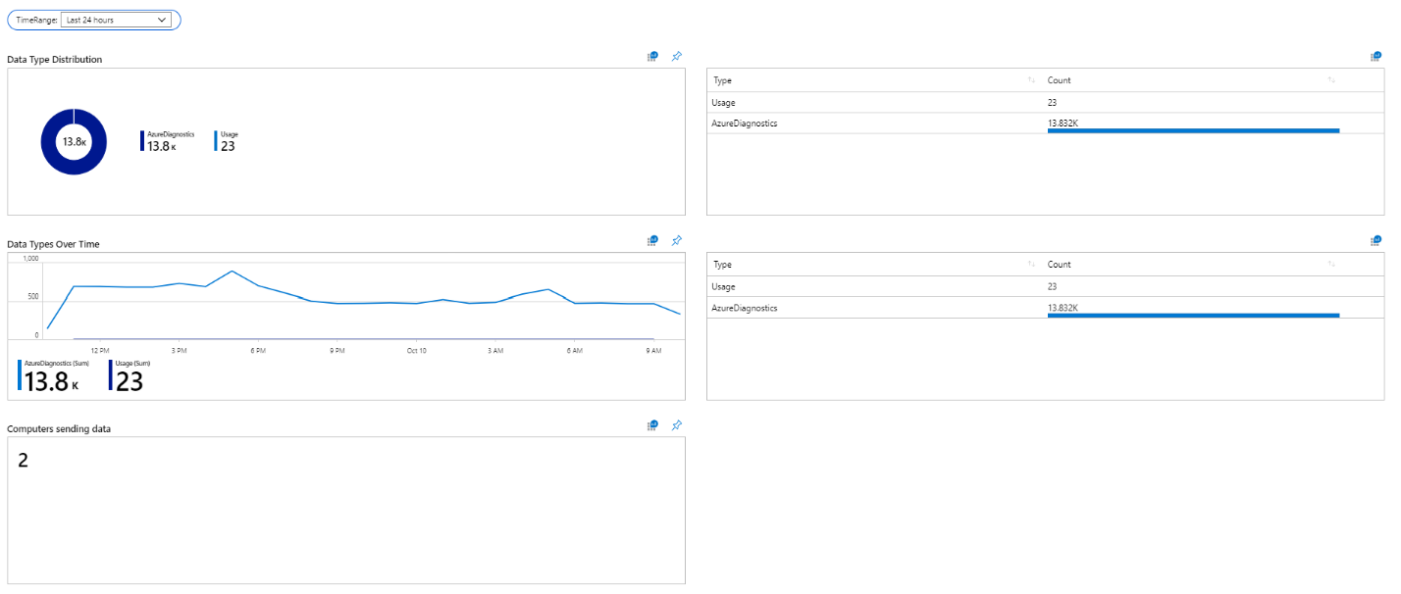

[View Designer - Tabbed](https://go.microsoft.com/fwlink/?linkid=874159&resourceId=%2Fsubscriptions%2F5c038d14-3833-463f-a492-de956f63f12a%2Fresourcegroups%2Faul-rg%2Fproviders%2Fmicrosoft.operationalinsights%2Fworkspaces%2Faul-test&featureName=Workbooks&itemId=%2Fsubscriptions%2F5c038d14-3833-463f-a492-de956f63f12a%2Fresourcegroups%2Faul-rg%2Fproviders%2Fmicrosoft.insights%2Fworkbooks%2F7b3240af-0f52-4b9a-abe6-e99010c9a780&workbookTemplateName=View%20Designer%20Tabbed&func=NavigateToPortalFeature&type=workbook)

Data Type Distribution Tab

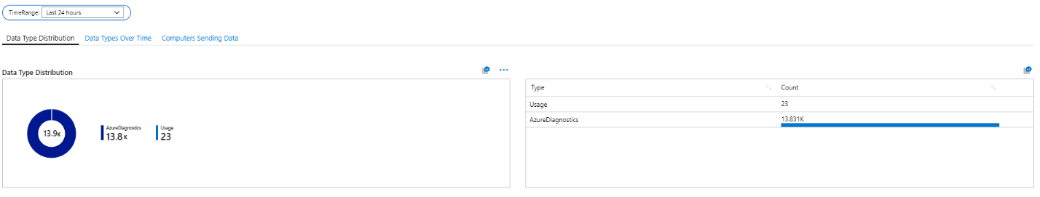

Data Types Over Time Tab

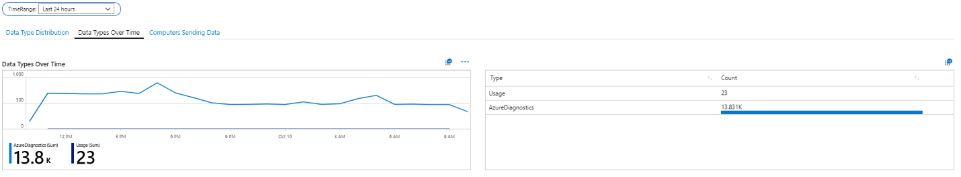

# Overview Tile Conversion

View Designer utilizes the overview tile feature to represent and summarize the overall state. These are represented in seven tiles, ranging from numbers to charts.

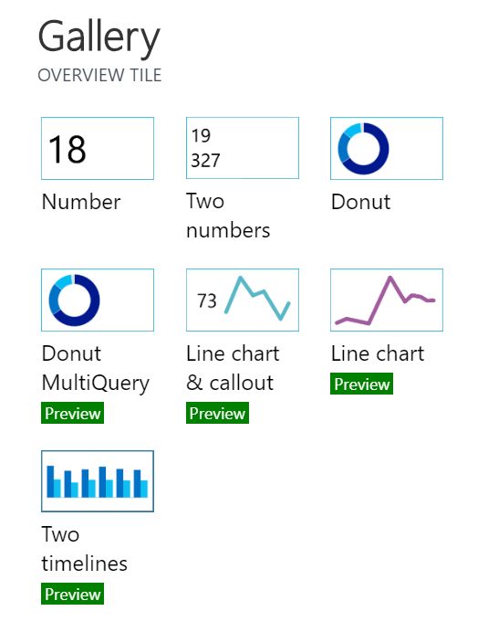

Within Workbooks, users can create similar visualizations and pin them to resemble the original style of overview tiles.

# View Dashboard Conversion

View Designer tiles typically consist of two sections, a visualization and a list that matches the data from the visualization, for example the Donut & List

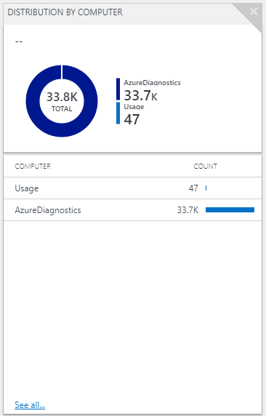

With Workbooks, we allow the user to choose to query one or both sections of the view. An example of how this view would be recreated in Workbooks is as follows:

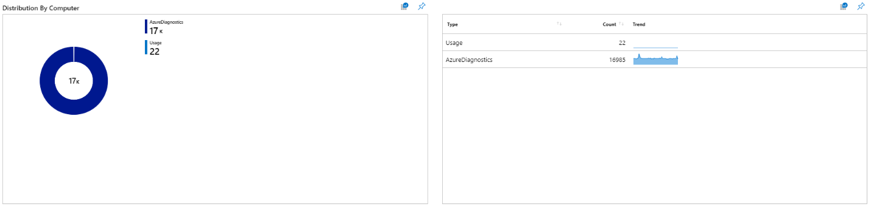

In general, formulating queries in Workbooks is a simple two-step process. First, the data is generated from the query, and the second, where the data is rendered as a visualization. The next set of sections breakdown commonly utilized steps to recreate View Designer views within workbooks.

The goal of these next sections is to demonstrate how to re-create 1-1 mappings of View Designer views, however, learning the various options enables users to create their own custom views in Workbooks.

## Getting Started

Just as with View Designer, you can create your Workbook within a Log Analytics workspace. By default the Workbook you create will query data from the current Log Analytics workspace. By setting up your parameters, you are able to query from other subscriptions, resources, and workspaces. (See the optional parameters section)

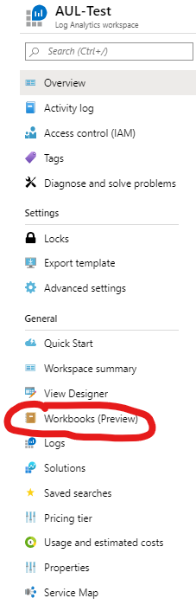

From there, you will see the Workbooks Gallery, where you can select from blank Workbooks canvases, templates, or previously created Workbooks.

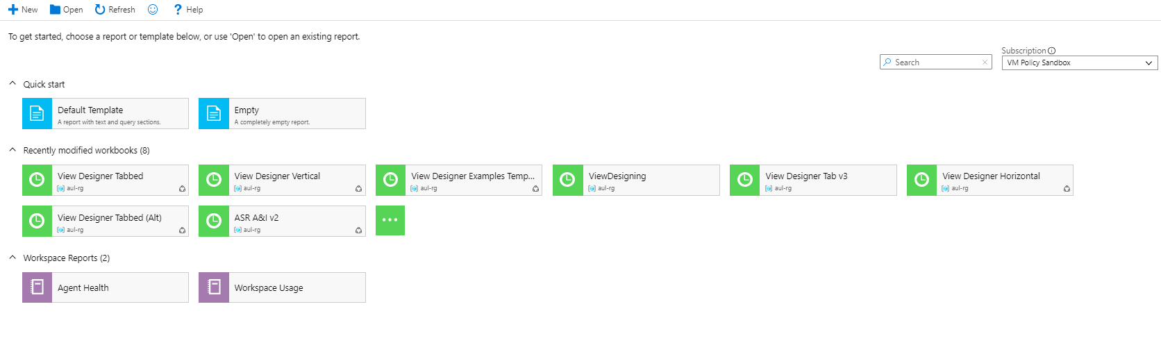

To begin from scratch, simply select an empty Workbook or choose a template you would like to utilize.

In the editing mode, you can start creating your Workbook by adding text, queries, metrics, parameters, or links.



## Updating Default View Designer Queries

The following sections provide specific examples utilizing the default queries generated from View Designer, however the data you wish to represent may differ from the default queries. Therefore, most, but not all updated Workbooks queries will have the same syntax.

By default, View Designer Queries will construct a global search query using “*search \**”. This query may not be appropriate for certain use cases, especially for larger sized logs. To analyze a certain subset of data, replace the “*search \**” keywords with a specific keyword such as “*AzureDiagnostics*”.

For example:

**Original:** *search * | summarize Count = count() by Type*

**Updated:** *search AzureDiagnostics | summarize Count = count() by Type*

To learn more about querying and KQL reference this [KQL guide](https://docs.microsoft.com/en-us/azure/kusto/query/).

## Common Steps

### Enabling Time Range Filter

View Designer has a built-in default Time Range filter, however, in Workbooks this setting is not enabled by default. Workbooks does allow users to create their own Time Range filters that might be more applicable to their data logs. The steps to generate the filter are listed below:

Select the **Add parameters** option  


The default Style is set to **Pills**

Select the **Add Parameter** button  
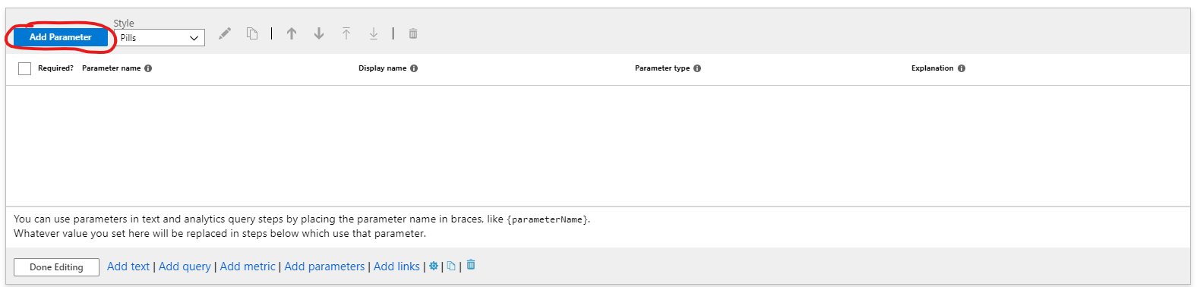

From the sidebar menu, in the **\* Parameter name** textbox, type “TimeRange”

Set **Parameter Type** as “Time Range Picker”

Select the “Required?” checkbox  
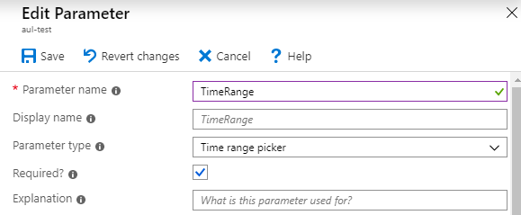

Save the parameter in the upper left hand corner of the sidebar menu

You can leave the dropdown as “<unset>” by default or select a default TimeRange value, such as 24 hours

Select **Done Editing**

### Updating the Query to Consider the TimeRange Parameter

**Option 1: Select TimeRange from the Time Range Dropdown for each query**

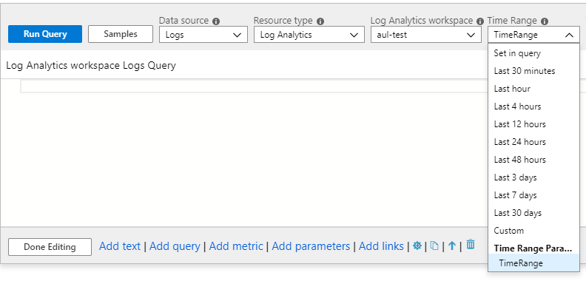

**Option 2: Update your KQL queries**

Within your query add this line: “*| where TimeGenerated {TimeRange}* ”

Example:

**Original:** *search * | summarize count() by Type*

**Updated:** *search* ***\* | where TimeGenerated {TimeRange}*** *| summarize count() by Type*

### Enabling Sparklines

A common feature for grids is to add sparklines to summarize various data patterns over time. View Designer offers the Enable Sparklines feature for all lists, as does Workbooks.

To include Sparklines in your data that match View Designer, you will need to join the data with your original query. You will need to add the following line

*| join kind = inner (search \**

*| make-series Trend = count() default=0 on TimeGenerated from {TimeRange:start} to {TimeRange:end} step {TimeRange:grain} by Type)*

*on Type*

Then under **Column Settings**

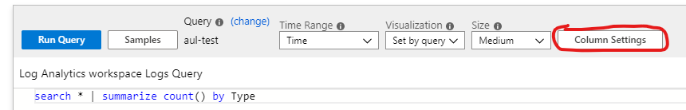Update the **Column renderer** dropdown to be a Spark area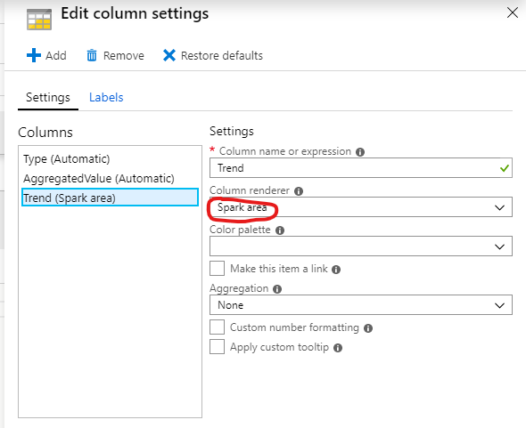

Then save the settings and re-running the query will now update your table to include a Sparkline

Example:

**Original:** *search \**

*| summarize AggregatedValue = count() by Type) on Type*

**Updated:** *search \**

*| summarize AggregatedValue = count() by Type*

***| join kind = inner (search \****

***| make-series Trend = count() default=0 on TimeGenerated from {TimeRange:start} to {TimeRange:end} step {TimeRange:grain} by Type***

***) on Type***

***| project Type, AggregatedValue, Trend***

Resulting grid will look similar to below:

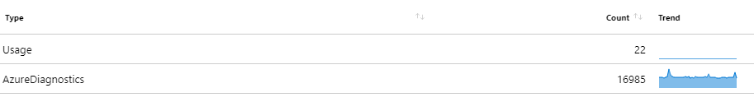

### Advanced Cell Settings

To mirror View Designer, some common steps such as changing the size of Workbook cells or adding pins and external links to logs might be utilized.

To access Advanced Settings select the gear icon at the bottom of each cell

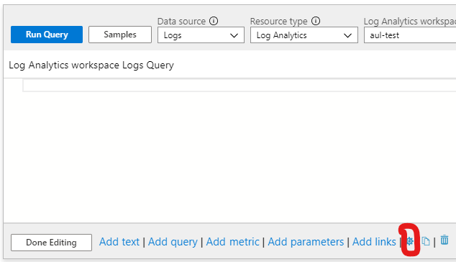

This will bring up a menu with various options

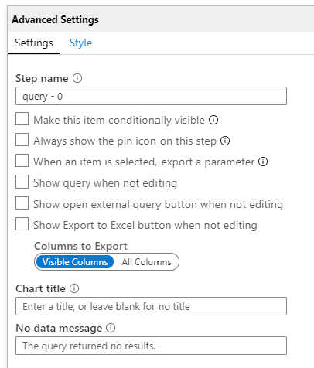

To add a pin and a link to an external query simply select the corresponding checkboxes.

To add a title to your cell, simply type the desired title into the **Chart title** section

By default any Workbooks cell is set to take up the entire page width, but users can adjust this by scaling the cell down, by clicking under the **Style** tab of the Advanced Settings menu

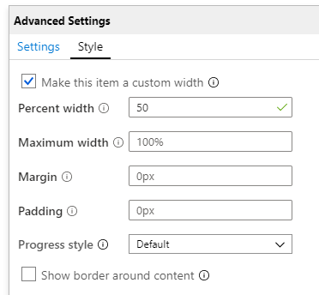

### Additional Parameters

Similar to the TimeRange Filter, you will need to select **Add Parameter**

For selecting a Subscription, type “Subscription” into the **Parameter name** field in the side menu and select “Subscription Picker”from the **Parameter type** dropdown

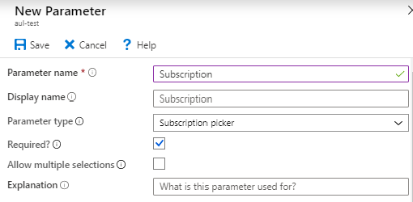

For selecting a Resource, type “Resource” into the **Parameter name** field in the side menu and select “Resource Picker”from the **Parameter type** dropdown

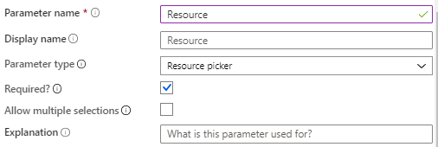

This will insert dropdowns to let you access your various subscriptions and resources

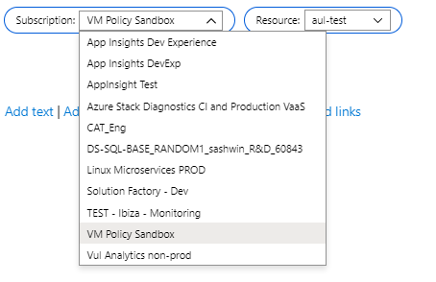

Now when you select **Add query**, you are able to choose other Log Analytics workspaces from the same or different subscriptions

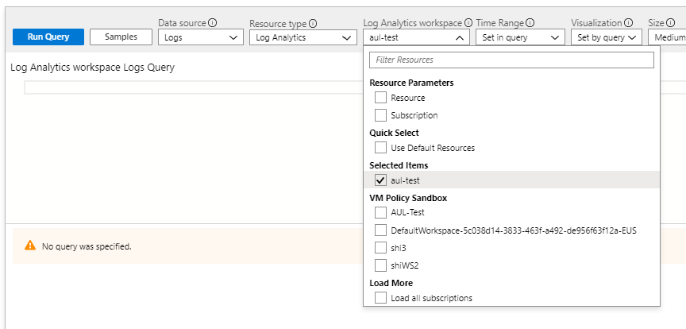

## Donut & List

View Designer has the Donut & List tile as shown below:



Recreating the tile in workbooks involves two queries, for the Donut portion there are two options.

Select **Add query** and paste the original query from View Designer into the cell

**Option 1: Select Pie Chart from the Visualization Dropdown**

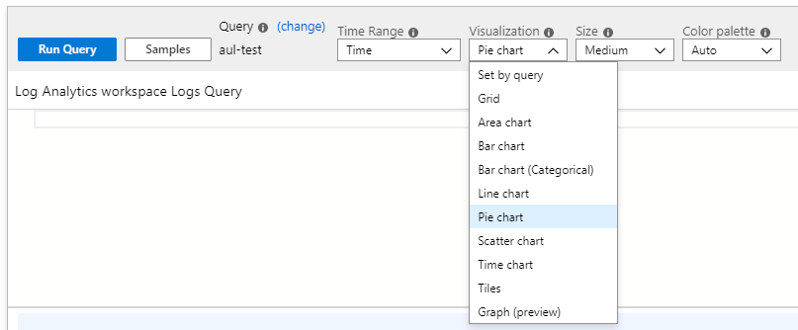

**Option 2: Add a line to the KQL**

**Add:** *| render piechart*

Note that the **Visualization** setting should be set to **Set by query**

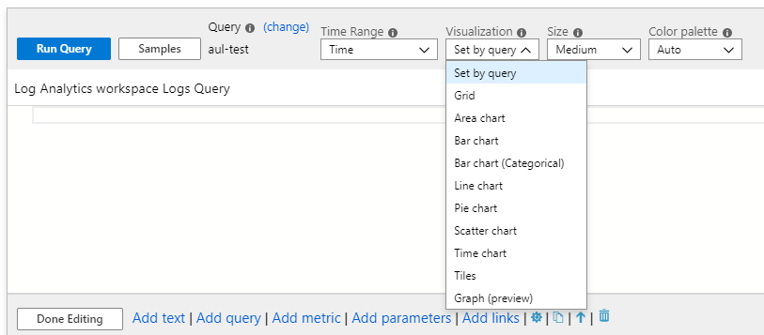

Example:

**Original:** *search * | summarize AggregatedValue = count() by Type | order by AggregatedValue desc*

**Updated:** *search * | summarize AggregatedValue = count() by Type | order by AggregatedValue desc* ***| render piechart***

For the latter half of the list, you will need to add an additional visualization by clicking **Add query**

The query syntax can be updated to such

**Original:** *search * | summarize AggregatedValue = count() by Type*

**Updated:** *search * | summarize* ***Count = count()*** *by Type*

To enable Sparklines follow the steps as shown in the Enabling Sparklines section

The following shows an example of how the tile might be represented within Workbooks



## Linechart & List

The original Linechart & List in View Designer looks like the following:

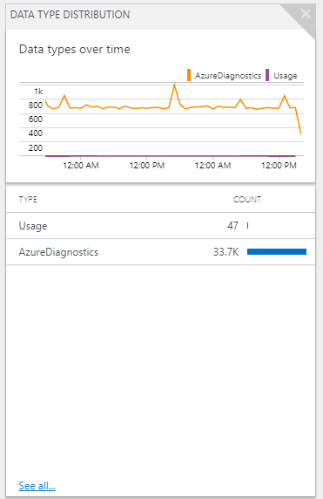

To recreate the Linechart portion we update the query as follows:

**Original:** *search * | summarize AggregatedValue = count() by Type*

**Updated:** *search \** ***| make-series Count = count() default=0 on TimeGenerated from {TimeRange:start} to {TimeRange:end} step {TimeRange:grain} by Type***

There are two options for visualizing the line chart

**Option 1: Select Line chart from the Visualization dropdown**

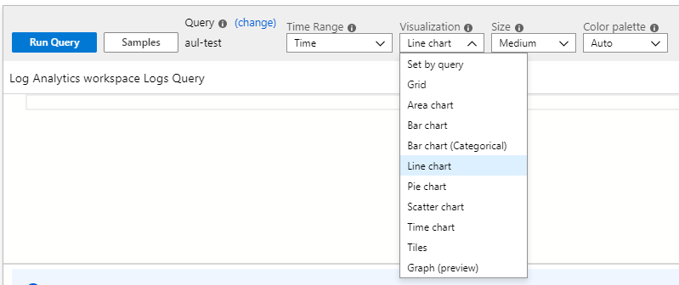

**Option 2: Add a line to the KQL**

**Add:** *| render linechart*

Note that the **Visualization** setting should be set to **Set by query**



Example:

*search * | make-series Count = count() default=0 on TimeGenerated from {TimeRange:start} to {TimeRange:end} step {TimeRange:grain} by Type* ***| render linechart***

For the list, simply modify your query as shown below

Original: *search * | summarize AggregatedValue = count() by Type*

Updated: *search * | summarize* ***Count = count()*** *by Type*

To enable Sparklines follow the steps as shown in the Enabling Sparklines section

The following shows an example of how the tile might be represented in Workbooks:

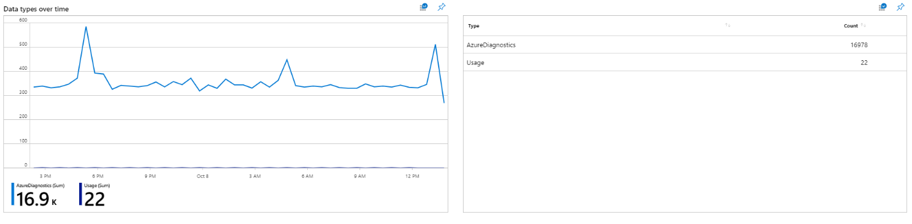

## Number & List

The original View Designer Number & List looks as such:

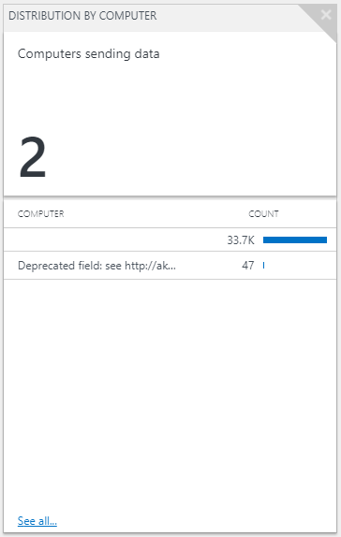

For the number tile

Update the query as such:

**Original:** *search * | summarize AggregatedValue = count() by Computer | count*

**Updated:** *search *| summarize AggregatedValue = count() by Computer* ***| summarize Count = count()***

Then change the Visualization dropdown to Tiles

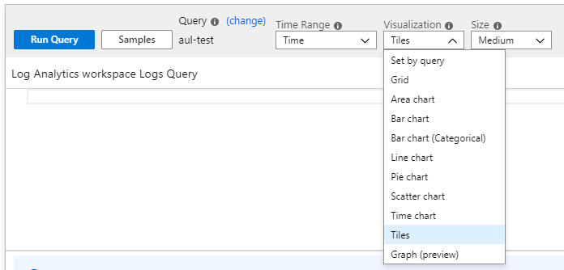

Select Tile Settings

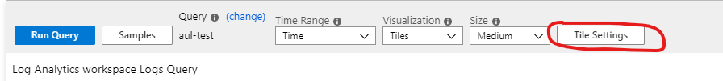

From the sidebar menu,

Set Visualization: Tiles

Tile Settings:

Title:

Left -> Use Column: Count

Column Renderer: Big Number

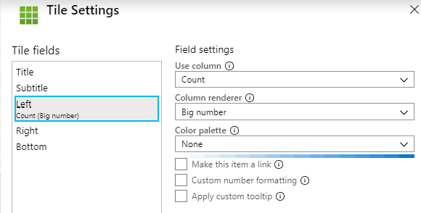

Advanced Settings \ Settings \ Chart title: Computers sending data

For the list, simply modify your query as shown below

Original: search * | summarize AggregatedValue = count() by Computer

Updated: search * | summarize **Count = count()** by Computer

To enable Sparklines follow the steps as shown in the Enabling Sparklines section

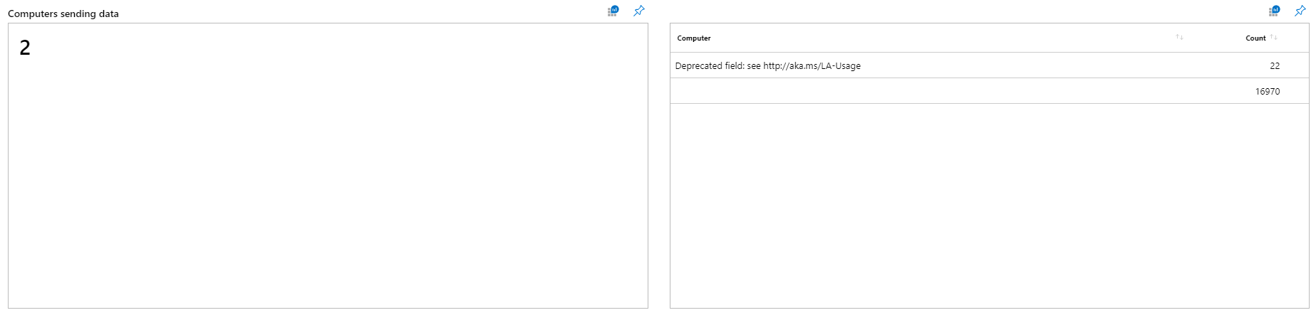

## Timeline & List

The Timeline & List in View Designer is shown below:

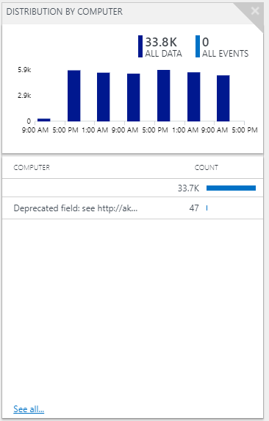

For the timeline simple update your query:

Original: search * | sort by TimeGenerated desc

Updated: search * **| summarize Count = count() by Computer, bin(TimeGenerated,{TimeRange:grain})**

There are two options for visualizing as a bar chart

**Option 1: Select Bar chart from the Visualization dropdown**

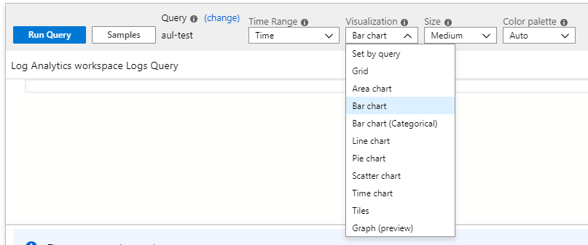

**Option 2: Add a line to the KQL**

**Add:** | render barchart

Note that the **Visualization** setting should be set to **Set by query**



For the list, simply modify your query as shown below

**Original:** search * | summarize AggregatedValue = count() by Type

**Updated:** search * | summarize **Count = count()** by Type

To enable Sparklines follow the steps as shown in the Enabling Sparklines section

Below is an example on how the tile might be represented within Workbooks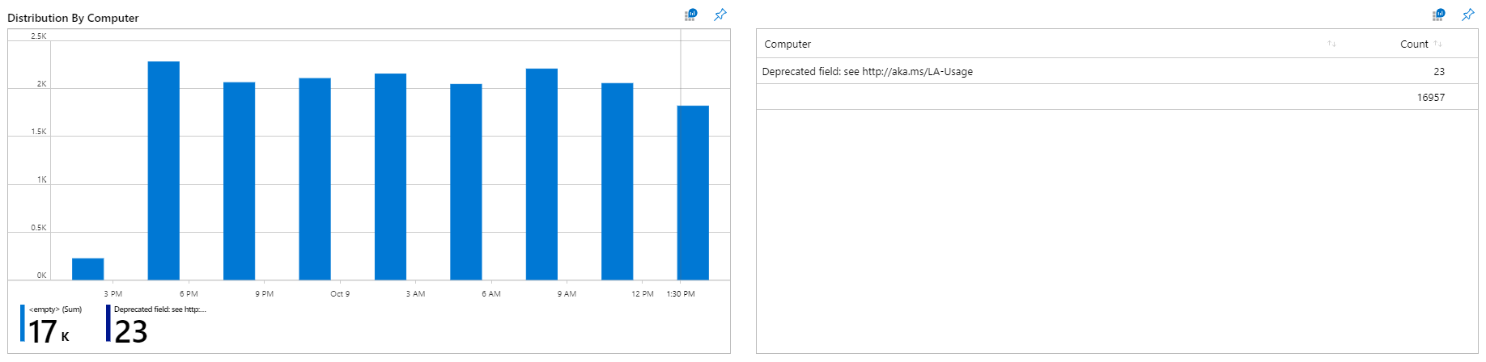

# Additional Reference Materials

[Link to examples of the queries](https://go.microsoft.com/fwlink/?linkid=874159&resourceId=%2Fsubscriptions%2F5c038d14-3833-463f-a492-de956f63f12a%2Fresourcegroups%2Faul-rg%2Fproviders%2Fmicrosoft.operationalinsights%2Fworkspaces%2Faul-test&featureName=Workbooks&itemId=%2Fsubscriptions%2F5c038d14-3833-463f-a492-de956f63f12a%2Fresourcegroups%2Faul-rg%2Fproviders%2Fmicrosoft.insights%2Fworkbooks%2Ff24eef39-1f73-4040-a037-b579b48174f2&workbookTemplateName=View%20Designer%20Examples%20Template&func=NavigateToPortalFeature&type=workbook)